LAB EXPERIMENT RECORD
Set 1: Monthly Sales Data

Department | AIML
Course Code / Course Name | DSA0601 / Data Handling and Visualization
Experiment | Data Visualization using R
Name | G.Ganga Chandrika
Register Number | 1925260144
Date | 29 September 2026
Day | Tuesday

Aim
To visualize monthly sales data using a line chart, a bar chart of top-selling products and a scatter plot of advertising budget against sales, and to build an interactive dashboard using R and Shiny.
Dataset: Monthly Sales and Advertising Budget
Month | Sales | Advertising Budget
Jan | 50000 | 10000
Feb | 55000 | 11000
Mar | 60000 | 12000
Apr | 58000 | 11500
May | 65000 | 13000
Jun | 70000 | 14000
Jul | 68000 | 13500
Aug | 75000 | 15000
Sep | 80000 | 16000
Oct | 85000 | 17000
Nov | 90000 | 18000
Dec | 95000 | 19000

Dataset: Top-Selling Products (Yearly)
Product | Total Sales
Laptop | 250000
Mobile | 220000
Tablet | 150000
Headphones | 100000
Smartwatch | 80000

PROGRAM 1: Line Chart of Monthly Sales
Create a line chart to visualize the monthly sales. Label the axes and title the chart appropriately.
# Dataset
sales <- data.frame(
Month = c("Jan","Feb","Mar","Apr","May","Jun",
"Jul","Aug","Sep","Oct","Nov","Dec"),
Sales = c(50000,55000,60000,58000,65000,70000,
68000,75000,80000,85000,90000,95000),
Advertising = c(10000,11000,12000,11500,13000,14000,
13500,15000,16000,17000,18000,19000)
)
# Line Chart
plot(sales$Sales,
type = "o",
xaxt = "n",
xlab = "Month",
ylab = "Sales",
main = "Monthly Sales")
axis(1, at = 1:12, labels = sales$Month)
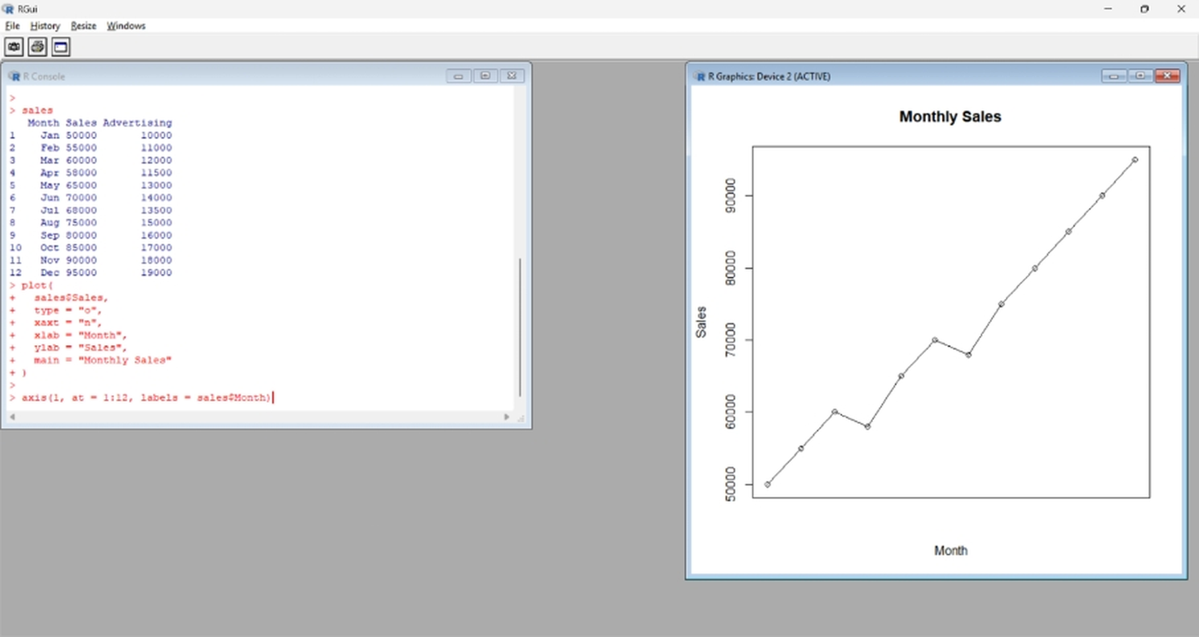
Output 1: Monthly Sales Line Chart
Observation: Sales rise steadily from 50,000 in January to 95,000 in December. The only dips are in April (58,000) and July (68,000); every other month is higher than the one before it, so the overall trend is clearly upward.

PROGRAM 2: Bar Chart of Top-Selling Products
Generate a bar chart to display the top-selling products for the year. Label the chart elements.
products <- data.frame(
Product = c("Laptop","Mobile","Tablet","Headphones","Smartwatch"),
Sales = c(250000,220000,150000,100000,80000)
)
# Bar Chart
barplot(products$Sales,
names.arg = products$Product,
col = "skyblue",
main = "Top-Selling Products",
xlab = "Product",
ylab = "Total Sales",
las = 2)
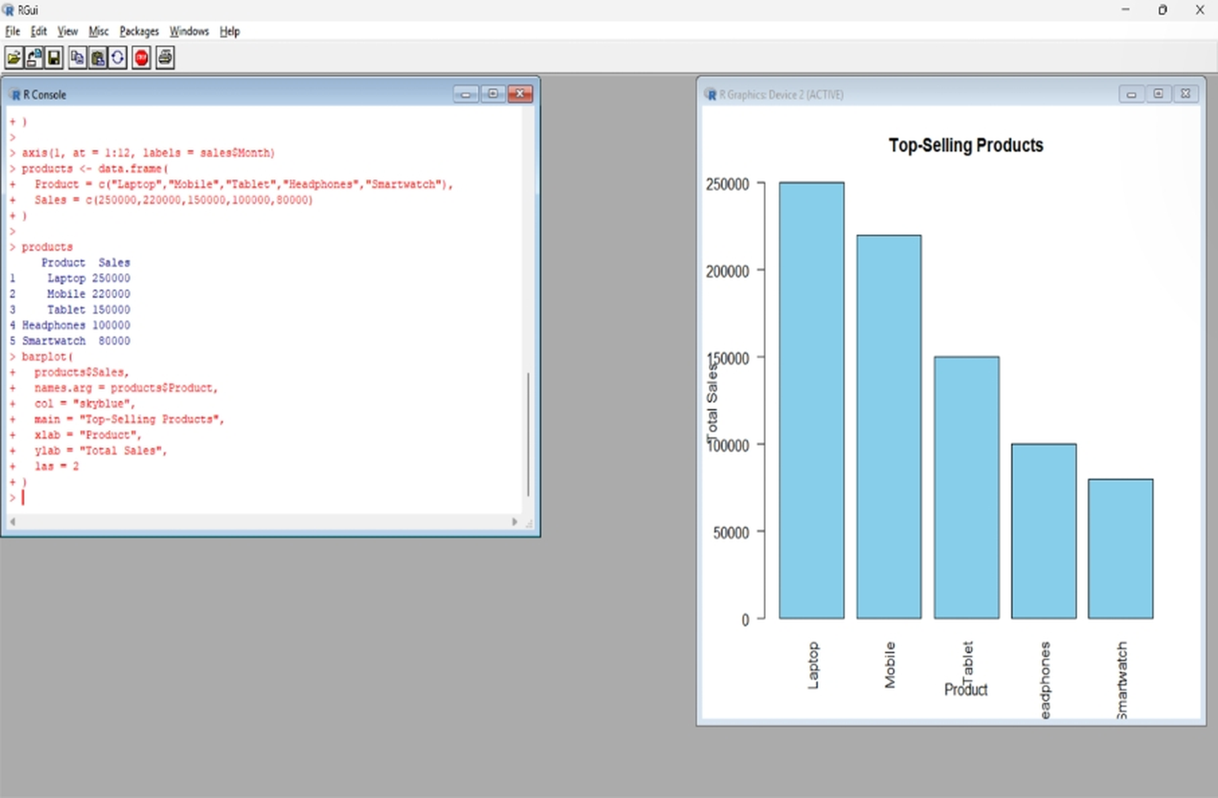
Output 2: Top-Selling Products Bar Chart
Observation: Laptop is the top-selling product (250,000), followed by Mobile (220,000) and Tablet (150,000). Headphones (100,000) and Smartwatch (80,000) sell the least. Laptop sales are about three times those of Smartwatch.

PROGRAM 3: Scatter Plot of Advertising Budget vs Monthly Sales
Develop a scatter plot to explore the relationship between advertising budget and monthly sales. Explain the insights drawn from the scatter plot.
# Scatter Plot
plot(sales$Advertising, sales$Sales,
main = "Advertising Budget vs Monthly Sales",
xlab = "Advertising Budget",
ylab = "Monthly Sales",
pch = 19)
# Regression (trend) line
abline(lm(Sales ~ Advertising, data = sales),
col = "red",
lwd = 2)
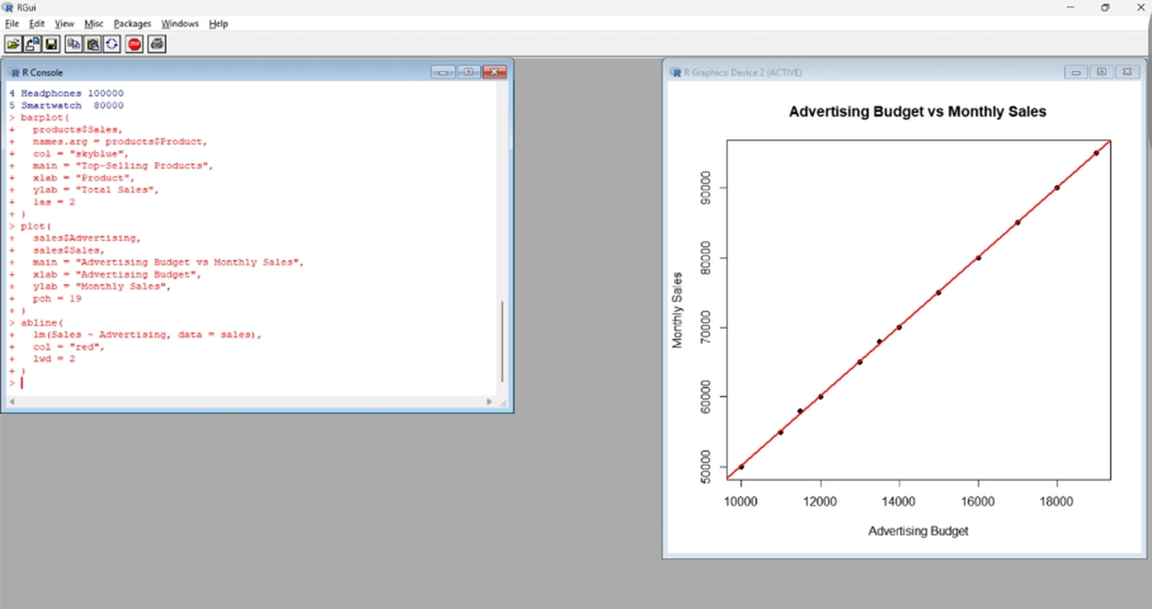
Output 3: Advertising Budget vs Monthly Sales Scatter Plot
Insights:
- The points lie almost exactly on the red regression line, showing a very strong positive linear relationship between advertising budget and monthly sales (correlation coefficient very close to 1).
- As the advertising budget rises from 10,000 to 19,000, monthly sales rise from 50,000 to 95,000. On the fitted line, each additional 1 unit of advertising is associated with roughly 5 units of additional sales.
- The two months with a small budget drop (April at 11,500 and July at 13,500) also show a small sales drop, which supports the link between the two variables.
- The data shows association, not proof of cause. Other factors such as seasonality or promotions could also affect sales, but higher advertising spending goes together with higher sales in this dataset.

PROGRAM 4: Interactive Sales Dashboard
Build an interactive dashboard combining the line chart and bar chart to allow users to explore sales data interactively, using the graphs above.
library(shiny)
# sales and products data frames as defined above
ui <- fluidPage(
titlePanel("Monthly Sales Dashboard"),
selectInput("month", "Select Month:",
choices = c("All", sales$Month)),
plotOutput("linePlot"),
plotOutput("barPlot")
)
server <- function(input, output) {
# Line chart (filtered by selected month)
output$linePlot <- renderPlot({
d <- if (input$month == "All") sales
else sales[sales$Month == input$month, ]
plot(d$Sales, type = "o", xaxt = "n",
xlab = "Month", ylab = "Sales",
main = "Monthly Sales")
axis(1, at = 1:nrow(d), labels = d$Month)
})
# Bar chart of top-selling products
output$barPlot <- renderPlot({
barplot(products$Sales,
names.arg = products$Product,
xlab = "Product", ylab = "Sales",
main = "Top-Selling Products", las = 2)
})
}
shinyApp(ui = ui, server = server)
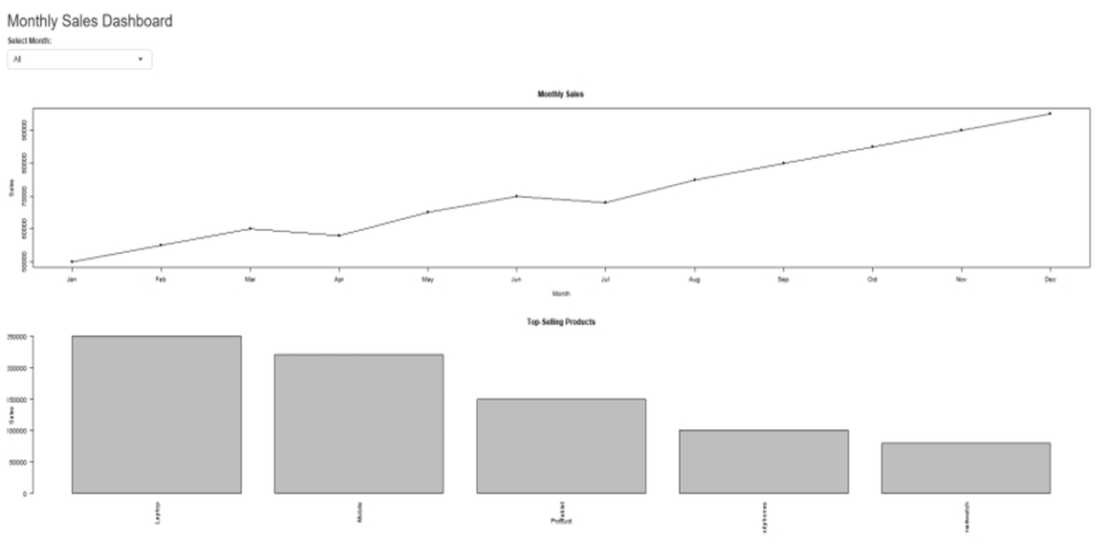
Output 4: Interactive Monthly Sales Dashboard
Observation: The dashboard shows the Monthly Sales line chart and the Top-Selling Products bar chart together on one page. The "Select Month" drop-down (default "All") lets the user choose all months or a single month to explore the sales data interactively.

Procedure
1. Create the sales data frame (Month, Sales, Advertising) and the products data frame in R.
2. Use plot() with type = "o" and axis() to create the line chart with labelled axes and a title.
3. Use barplot() on the products data frame to show the top-selling products with labels and a title.
4. Use plot() to draw the scatter plot of Advertising vs Sales, and add a regression line with abline(lm()).
5. Install and load the Shiny package, then create the UI (selectInput and plotOutput) and the server (renderPlot) for the dashboard.
6. Run shinyApp() and use the month selection box to explore the charts.
Result
The monthly sales data was successfully visualized using a line chart, a bar chart of top-selling products and a scatter plot. The scatter plot showed a very strong positive relationship between advertising budget and sales, and an interactive Shiny dashboard combining the line and bar charts was created.
Key R Functions Used
Function | Purpose
data.frame() | Creates the sales and products datasets.
plot() | Creates line and scatter plots.
axis() | Adds custom axis labels (months).
barplot() | Creates the bar chart.
abline() / lm() | Fits and draws the regression line on the scatter plot.
fluidPage() | Creates the Shiny page layout.
selectInput() | Provides the month selection control.
renderPlot() | Generates plots dynamically in Shiny.
shinyApp() | Runs the interactive Shiny application.

